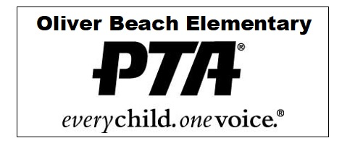

**OLIVER BEACH ELEMENTARY SCHOOL PTA**

**12912 Cunninghill Cove Rd, Baltimore, MD 21220**

[**oliverbeachpta@gmail.com**](mailto:oliverbeachpta@gmail.com) **|** [**www.oliverbeachpta.org**](http://www.oliverbeachpta.org) **|** [**(443) 809-5943**](https://www.google.com/search?client=safari&rls=en&q=oliver+beach+elementary+school&ie=UTF-8&oe=UTF-8)

____________________________________________________________________________

Daria Greensfelder - President Morgan Wood- Vice President Caitlin Wood- Treasurer

Jaimie Schorr- Recording Secretary Kelsie Wagner - Corresponding Secretary

_____________________________________________________________________________

**PTA SUPPORT REQUEST & REIMBURSEMENT FORM**

**STEP 1: REQUEST APPROVAL**

Please complete the form below and email to the PTA at [Oliverbeachpta@gmail.com](mailto:Oliverbeachpta@gmail.com) or place in the PTA Mailbox

Date: _________________________

Teacher Name(s):____________________________________________________________

Phone/Email:_________________________________________________________________

Grade:_____________________________________________________________________

Items Requested:

_______________________________________________________________________

_______________________________________________________________________

_______________________________________________________________________

_______________________________________________________________________

_______________________________________________________________________

Purpose:

_______________________________________________________________________

_______________________________________________________________________

_______________________________________________________________________

_______________________________________________________________________

_______________________________________________________________________

Approximate Cost:

_______________________________

PTA Signature:

______________________________________________ Date:___________________

______­­­­­­­­­­­­­­­­­­­­­­­­­­­­­­­­­­­­­­­­­­­­­­­­________________________________________ Date:___________________

**STEP 2: SUBMIT INVOICES/RECEIPTS**

You will receive this form back from the PTA with approval to make your expenditure(s). Make your expenditures (or obtain a PO). Attach you receipts or invoices to this form, and re‐submit in the PTA mailbox.

**PTA TEACHER SUPPORT FUNDS**

You are eligible for modest monetary grants to support your classroom educational environment. These monies may be used for any classroom educational purpose (i.e., no class parties), as long as they serve all students equally and not any one subgroup.

• Requests require approval of the Principal and PTA President.

• Funds are issued as a reimbursement or toward payment of a PO.

• These monies may not be carried over into the following academic year.

Please submit the form to the PTA for approval first before making your expenditures. We will return the form to you with approval. After making your purchase, re‐submit the form to the PTA with your receipt or invoice. If you have any questions about the funds or the expense approval and reimbursement process, please email PTA.